**Artificial and Computational Intelligence**

**Assignment 1**

**Problem statement: 22**

Consider a scenario where a rabbit is trapped on cave. Given below is the picture of a cave as a grid. The task of the rescue robot is to help the rabbit to find the optimal path to reach the finish position. It can move to the north, south, west and east direction. While navigating through the environment it has obstacles like walls, fire and Bush plant. For each transition, a path cost of +3 is added in search. Assume that the robot’s vision sensors are sensitive to the exposure to the fire and whenever it tries to move towards the fire cell resulting in incurring an additional penalty of +5 cost. In addition, every time the rabbit attempts to move towards the bush plant cell, an extra transition cost of +1 is incurred. Use Manhattan distance as a heuristic wherever necessary.

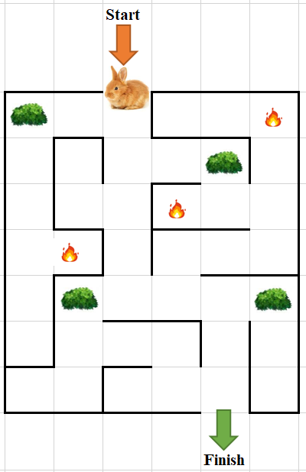

***Use the following algorithms to find the optimal path.***

* ***A* Algorithm***
* ***Random Restart Hill Climbing Algorithm***

**Evaluations will be based on the following.**

1. Explain the PEAS and Task environment of the agent [3 Mark]

2. Define the heuristic and or fitness function for the given algorithms and the given problem. [2 Mark]

3. Use appropriate data structures and implement search algorithms (informed and local search). The starting point is to be obtained from the user as input. [3+3 =6 Mark]

4. Find and print space and time complexity using code in your implementation. [2 Mark]

**NOTE:**

* You are provided with the python notebook template which stipulates the structure of code and documentation. Use well intended python code.
* Use separate MS word document for explaining the theory part [PEAS & Task environment]. Do not include theory part in the Python notebook except Python comments.
* The implementation code must be completely original and executable.
* Please keep your work (code, documentation) confidential. If your code is found to be plagiarized, you will be penalized severely. **Parties involved in the copy will be considered equal partners and will be penalized severely.**